The Clifton Show Society
Presents
The 2025 Clifton Show Dashshund Dash
Saturday the 15th OF Febuary 2025
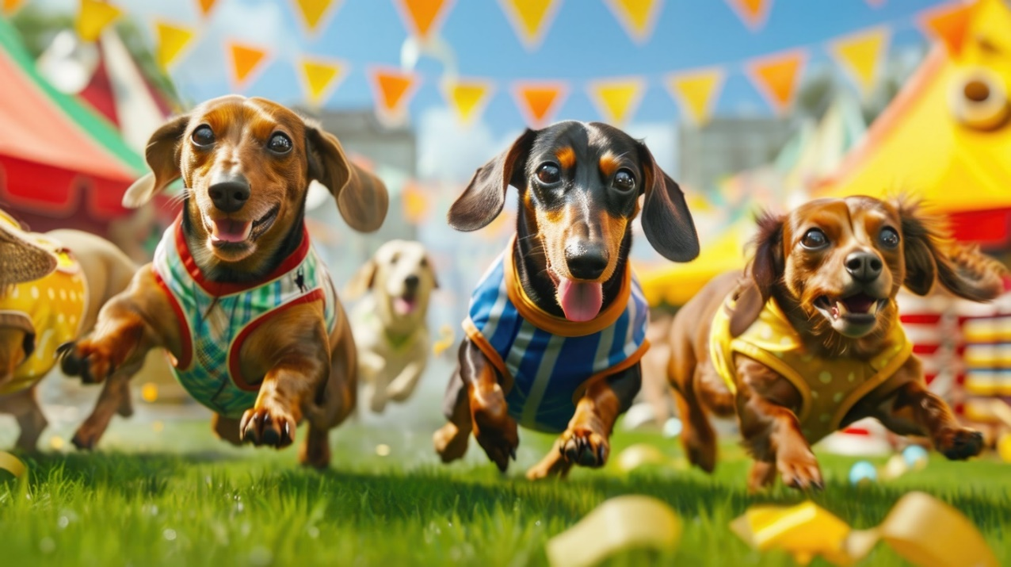

Nominate by contacting Olivia Raeburn
olivia.raeburn@hotmail.com or Phone 0400702436
Nominations are limited so get in quick!

4pm sign in for 4.30 Racing!
Main Grandstand – Centre ring!

Proudly sponsored by
Dust’s Clifton!

